BREAKFAST CHATTER
Weekly Bulletin of Rotary Club of Kathmandu Mid-Town
District 3290 Volume No. 15/37 for #779 April 08, 2005
www.rotarymidtown.org.np
APRIL IS THE MAGAZINE MONTH
I hope that Lisa will be with us to celebrate her birthday on our very meeting day, Friday the 8th! Happy Birthday Lisa.
****************
MEETINGS & ACTIVITIES:

DATE | ACTIVITY | SUBJECT
8 APR | PEMA KHANDO | FASHION DEVELOPMENT IN NEPAL
9 APR | CLUB PICNIC | IN DHULIKHEL (CATERED, NOT POTLUCK!)
15 APR | ROBIN BRADSHAW | LONDON TO CAPETOWN AND BACK BY SCOOTER  (IN HIS YOUTH)
22 APR | CLUB ASSEMBLY | PROGRESS REPORTS
29 APR | SOM PANERU | OVERCOMING KAMLARIA
06 May | open
13 May | open
20 May | AMOD MANI DIXIT | DO THIS BEFORE TOMORROW’S EARTHQUAKE

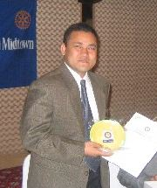
****** ←Sushil Man Singh Pradhan was our guest speaker last Friday. His subject: the story of the Technical and Skill Development Centre for the Blind and Disabled located in Dhulikhel. This school offers lifelong skills.

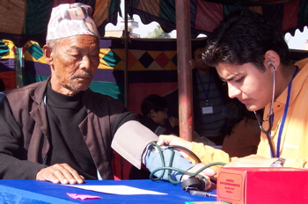
****** We will try again for an enjoyable outing together this weekend to Dhulikhel. A number of members have already indicated they have travel or other plans, so we will do a head count at the Friday meeting to see if there is a ‘picnic quorum’.

****** A ‘memorable moment’ from last November’s health camp. → → →

****** Tomorrow’s guest speaker will be Pema Khando, an apparel entrepreneur.

Hope to see you on Friday morning. YIR…David

